Basic Networking Mid Exam – TS Engineer 120’
Name :
Correct Answers :
Incorrect Answers :
Note: + You can answer either by circle the correct answer(s) or write down your selection at the “Answer: ”
+ Be careful with the multiple choice question. It’s single choice if the question is not mentioned as a multiple choice

QUESTION 01
The LAN needs are expanding at the GCS office, which is quickly growing. You are instructed to enlarge the area covered by a single LAN segment on the GCS network. Which of the following are layer 1 devices that you can use? (Choose two)
A. A switch.
B. A router.
C. A network adapter card.
D. A hub.
E. A repeater.
Answer: D,E

QUESTION 02
While troubleshooting a connectivity problem on the network, you issue the ping command from your PC command prompt, but the output shows "request times out."
At which OSI layer is this problem associated with?
A. The data link layer
B. The application layer
C. The access layer
D. The session layer
E. The network layer
Answer: E

QUESTION 03
You download a file from an FTP site on the Internet. What is the highest layer in the OSI model used in this FTP operation?
A. Application
B. Presentation
C. Session
D. Transport
E. Internet
F. Data Link
G. Physical
Answer: A

QUESTION 04
Which of the following protocols operate at the 'Application layer' of the OSI model? (Select two)
A. TCP
B. Telnet
C. FTP
D. ARP
E. IP
F. None of the above
Answer: B,C

QUESTION 05
In the communications industry, what are the features and benefits of using the layered OSI model?
(Select two)
A. It encourages industry standardization by defining what functions occur at each layer of the model.
B. It necessitates changes in functionality in one layer to other layers.
C. It enables equipment efficiency from different vendors to use the same electronic components.
D. It divides the network communication process into smaller and simpler components, thus aiding
component development, design, and troubleshooting.
E. It supports the evolution of multiple competing standards, and thus enhances business equipment
manufacturing opportunities.
Answer:A,D

QUESTION 06
The TCP/IP network model differs from the more popular OSI model. Which of the layers below belong to the TCP/IP model? (Select three)
A. application layer
B. session layer
C. transport layer
D. internet layer
E. network layer
F. data link layer
G. physical layer
Answer:A,C,E

QUESTION 07
At which layer of the OSI model is the optimal path to a network destination determined at?
A. Data Link
B. Session
C. Physical
D. Presentation
E. Network
F. Transport
Answer:E

QUESTION 08
Which one of the following is the most commonly used layer 2 network device?
A. Hub
B. Bridge
C. Switch
D. Router
E. Repeaters
F. None of the above
Answer:C

QUESTION 09
Which of the UTP/STP cable types are used in the A or B or C scenario? (Write three answer below, for example if you think crossover should be used for the scenario X, so you answer: x - 1)

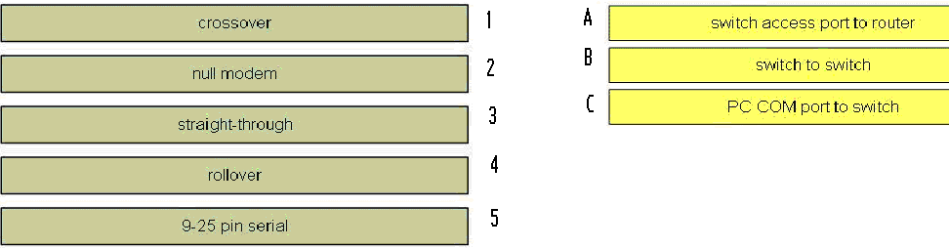

Answer:
A –3
B – 1
C – 4

QUESTION 10
Which of the following layers of the TCP/IP model most closely corresponds to the network layer of the OSI model?
A. Application
B. Internet
C. Transport
D. Network
E. Data Link
Answer:B

QUESTION 11
What does the term computer language refer to?
A. Binary
B. Decimal
C. Hexadecimal
D. Octal
E. All of the above
Answer:A

QUESTION 12

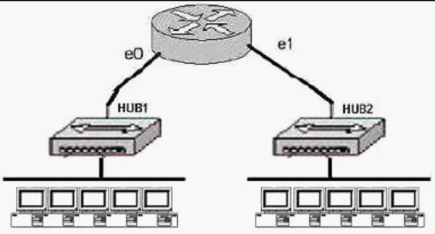
Based on the diagram above, how many collision domains are present in the GCS network?
A. One
B. Two
C. Three
D. Four
E. Five
F. Six
G. Fourteen
Answer:B

QUESTION 13

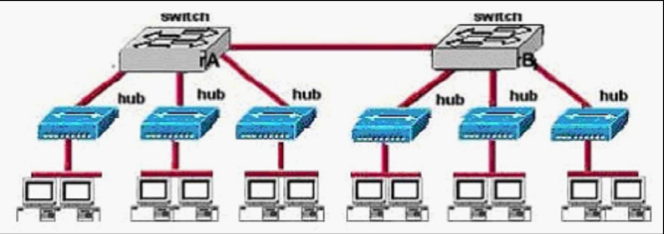
How many broadcast domains are shown in the graphic?

A. One
B. Two
C. Six
D. Twelve
Answer:A

QUESTION 14
The GCS LAN consists of one large flat network. You decide to segment this LAN into two separate networks with a router. What will be the affect of this change?
A. The number of broadcast domains will be decreased.
B. It will make the broadcasting of traffic between domains more efficient between segments.
C. It will increase the number of collisions.
D. It will prevent segment 1's broadcasts from getting to segment 2.
E. It will connect segment 1's broadcasts to segment 2.
Answer:D

QUESTION 15
A brand new network application is required for the GCS Company, and they are considering the use
of a connectionless service. What are the characteristics of a connectionless service? (Select two
answer choices)
A. It uses a Reliable transport mechanism.
B. It uses a Non-reliable transport mechanism
C. It is less bandwidth-intensive than connection oriented services
D. it uses handshaking
Answer:B,C

QUESTION 16
Which of the following statements correctly describe the differences between half-duplex and fullduplex
Ethernet? (Select two answer choices.)
A. Full-duplex Ethernet uses CSMA/CD to prevent collisions.
B. Half-duplex Ethernet uses CSMA/CD to detect collisions.
C. A full-duplex Ethernet card allows 20Mbps for data transmission.
D. Full-duplex Ethernet makes use of two pairs of wires for data.
E. An Ethernet hub can operate both half and full duplex simultaneously.
Answer:B,D

QUESTION 17
Why is full-duplex Ethernet superior to its single-duplex counterpart? (Select two answer choices.)
A. It uses inexpensive hubs
B. It operates without collisions
C. It operates on switches
D. It provides faster data transfer
E. It utilizes fewer wiring pairs
Answer:B,D

QUESTION 18
When you compare the differences between half-duplex and full-duplex Ethernet, which of the
following characteristics are exclusive to half-duplex? (Select two answer choices)
A. Half-duplex Ethernet operates in a shared collision domain.
B. Half-duplex Ethernet operates in an exclusive broadcast domain.
C. Half-duplex Ethernet has efficient throughput.
D. Half-duplex Ethernet has lower effective throughput.
E. Half-duplex Ethernet operates in an exclusive collision domain.
Answer:A,D

QUESTION 19
Two stations on a LAN transmit at the same time, resulting in a collision. What happens when a
collision occurs on the network? (Choose three)
A. Each device on the Ethernet segment stops transmitting for a short time.
B. A jam signal informs all devices that a collision occurred.
C. When data transmission resumes, the devices that were involved in the collision have priority to transmit.
D. The devices that are involved in the collision stops transmitting for a short time.
E. The collision invokes a random back-off algorithm.
Answer:B,D,E

QUESTION 20
With regard to bridges and switches, which of the following statements are true? (Choose three.)
A. Switches are primarily software based while bridges are hardware based.
B. Both bridges and switches forward Layer 2 broadcasts.
C. Bridges are frequently faster than switches.
D. Switches typically have a higher number of ports than bridges.
E. Bridges define broadcast domain while switches define collision domains.
F. Both bridges and switches make forwarding decisions based on Layer 2 addresses.
Answer:B,D,F

QUESTION 21
Which Layer 1 devices can be used to enlarge the area covered by a single LAN segment? (Select two)
A. Switch
B. Router
C. NIC
D. hub
E. Repeater
F. RJ-45 transceiver
Answer:D,E

QUESTION 22
Given the choices below, which ip address represents a unicast address?
A. 224.1.5.2
B. 240.1.1.100
C. 192.168.24.59/30
D. 255.255.255.255
E. 172.31.128.255/18
Answer:E

QUESTION 23
If a host on a network has the address 172.16.45.14/30, what is the address of the subnetwork to which this host belongs?
A. 172.16.45.0
B. 172.16.45.4
C. 172.16.45.8
D. 172.16.45.12
E. 172.16.45.18
Answer:D

QUESTION 24
The subnet mask on the serial interface of a router is expressed in binary as 11111000 for the last
octet. How do you express the binary number 11111000 in decimal?
A. 210
B. 224
C. 240
D. 248
E. 252
Answer:D

QUESTION 25
How would the number 231 be expressed as a binary number?
A. 11011011
B. 11110011
C. 11100111
D. 11111001
E. 11010011
Answer:C

QUESTION 26
How do you express the binary number 10110011 in decimal form?
A. 91
B. 155
C. 179
D. 180
E. 201
F. 227
Answer:C

QUESTION 27
Which two of the addresses below are available for host addresses on the subnet 192.168.15.19/28?
(Select two answer choices)
A. 192.168.15.17
B. 192.168.15.14
C. 192.168.15.29
D. 192.168.15.16
E. 192.168.15.31
F. None of the above
Answer:A,C

QUESTION 28
How many subnetworks and hosts are available per subnet if you apply a /28 mask to the 210.10.2.0 class C network?
A. 30 networks and 6 hosts.
B. 6 networks and 30 hosts.
C. 8 networks and 32 hosts.
D. 32 networks and 18 hosts.
E. 14 networks and 14 hosts.
F. None of the above
Answer:E

QUESTION 29
What is the subnet for the host IP address 172.16.210.0/22?
A. 172.16.42.0
B. 172.16.107.0
C. 172.16.208.0
D. 172.16.252.0
E. 172.16.254.0
F. None of the above
Answer:C

QUESTION 30
Three addresses are shown in binary form below:
A. 01100100.00001010.11101011.00100111
B. 10101100.00010010.10011110.00001111
C. 11000000.10100111.10110010.01000101
Regarding these three binary addresses in the above information; which statements below are correct?
(Select three)
A. Address C is a public Class C address.
B. Address C is a private Class C address.
C. Address B is a public Class B address.
D. Address A is a public Class A address.
E. Address B is a private Class B address.
F. Address A is a private Class A address.
Answer:A,D,E

QUESTION 31
What is the IP address range for the first octet in a class C address, in binary form?
A. 00000111-10001111
B. 00000011-10011111
C. 10000000-10111111
D. 11000000-11011111
E. 11100000-11101111
F. None of the above
Answer:D

QUESTION 32
The GCS network consists of 5 different departments as shown below:
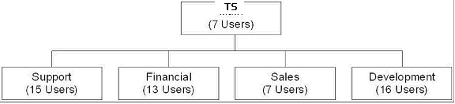
You are a systems administrator at GCS and you've just acquired a new Class C IP network. Which
of one of the subnet masks below is capable of providing one useful subnet for each of the above
departments (TS, support, financial, sales & development) while still allowing enough usable host
addresses to meet the needs of each department?
A. 255.255.255.128
B. 255.255.255.192
C. 255.255.255.224
D. 255.255.255.240
E. 255.255.255.248
F. 255.255.255.252
Answer:C

QUESTION 33
Using a subnet mask of 255.255.255.224, which of the IP addresses below can you assign to the hosts on this subnet? (Select three)
A. 16.23.118.63
B. 87.45.16.159
C. 92.11.178.93
D. 134.178.18.56
E. 192.168.16.87
F. 217.168.166.192
Answer:C,D,E

QUESTION 34
The IP network 210.106.14.0 is subnetted using a /24 mask. How many usable networks and host addresses can be obtained from this?
A. 1 network with 254 hosts
B. 4 networks with 128 hosts
C. 2 networks with 24 hosts
D. 6 networks with 64 hosts
E. 8 networks with 36 hosts
Answer:A

QUESTION 35
Given that you have a class B IP address network range, which of the subnet masks below will allow
for 100 subnets with 500 usable host addresses per subnet?
A. 255.255.0.0
B. 255.255.224.0
C. 255.255.254.0
D. 255.255.255.0
E. 255.255.255.224
Answer:C

QUESTION 36
The 213.115.77.0 network was subnetted using a /28 subnet mask. How many usable subnets and host
addresses per subnet were created as a result of this?
A. 2 networks with 62 hosts
B. 6 networks with 30 hosts
C. 16 networks and 16 hosts
D. 62 networks and 2 hosts
E. 14 networks and 14 hosts
F. None of the above
Answer:E

QUESTION 37
The 201.145.32.0 network is subnetted using a /26 mask. How many networks and IP hosts per
network exists using this subnet mask?
A. 4 networks with 64 hosts
B. 64 networks and 4 hosts
C. 2 networks and 62 hosts
D. 62 networks and 2 hosts
E. 6 network and 30 hosts
Answer:C

QUESTION 38
You have a class B network with a 255.255.255.0 mask. Which of the statements below are true of this
network? (Select two)
A. There are 254 usable subnets.
B. There are 256 usable hosts per subnet.
C. There are 50 usable subnets.
D. There are 254 usable hosts per subnet.
E. There are 24 usable hosts per subnet.
F. There is one usable network.
Answer:A,D

QUESTION 39
Which of the following IP addresses is a private IP address? (Select two)
A. 12.0.0.1
B. 168.172.19.39
C. 172.20.14.36
D. 172.33.194.30
E. 192.168.42.34
Answer:C,E

QUESTION 40
If an Ethernet port on router was assigned an IP address of 172.16.112.1/20, what is the maximum
number of hosts allowed on this subnet?
A. 1024
B. 2046
C. 4094
D. 4096
E. 8190
Answer:C

QUESTION 41
You work as network consultant. Your customer, DTV, has a class C network license. DTV
wants you to subnet the network to provide a separate subnet for each of its 5 departments. Each
subnet must support at least 24 hosts. Which network mask should you use?
A. 255.255.255.192
B. 255.255.255.224
C. 255.255.255.240
D. 255.255.255.248
E. 255.255.255.252
F. 255.255.255.254
Answer:B

QUESTION 42
Your friend in GCS asks you what 11111001 binary is in decimal. What should you tell him?
A. 6
B. 193
C. 225
D. 241
E. 249
Answer:E

QUESTION 43
What is the maximum number of IP addresses that can be assigned to hosts on a local subnet that
use the 255.255.255.224 subnet mask?
A. 14
B. 15
C. 16
D. 30
E. 31
F. 32
Answer:D

QUESTION 44
Which of the following IP addresses for the network 27.35.16.32/28 can be assigned to hosts?
(Choose three)
A. 27.35.16.32
B. 27.35.16.33
C. 27.35.16.48
D. 27.35.16.47
E. 27.35.16.45
F. 27.35.16.44
Answer:B,E,F

QUESTION 45
You are a systems administrator and you are about to assign static IP addresses to various servers on your network. For the network 192.168.20.24/29 the ICT server is assigned to the first usable host address, while the last usable host address goes to your TS server. Which one of the following commands would you enter into the IP properties box of the TS server?
A. IP address: 192.168.20.14
Subnet Mask: 255.255.255.248
Default Gateway: 192.168.20.9
B. IP address: 192.168.20.254
Subnet Mask: 255.255.255.0
Default Gateway: 192.168.20.1
C. IP address: 192.168.20.30
Subnet Mask 255.255.255.248
Default Gateway: 192.168.20.25
D. IP address: 192.168.20.30
Subnet Mask 255.255.255.240
Default Gateway: 192.168.20.17
E. IP address: 192.168.20.30
Subnet Mask 255.255.255.240
Default Gateway: 192.168.20.25
Answer:C

QUESTION 46
Which of the following addresses can be assigned to a host when using a subnet mask of
255.255.254.0? (Select three)
A. 113.10.4.0
B. 186.54.3.0
C. 175.33.4.255
D. 26.35.3.255
E. 152.135.7.0
F. 17.35.36.0
Answer:B,D,F

QUESTION 47
You have the binary number 10011101. Convert it to its decimal and hexadecimal equivalents. (Select two
answer choices)
A. 158
B. 0x9D
C. 156
D. 157
E. 0x19
F. 0x9F
Answer:B,D

QUESTION 48
Your network uses the 172.12.0.0 class B address. You need to support 459 hosts per subnet, while accommodating the maximum number of subnets. Which mask would you use?
A. 255.255.0.0.
B. 255.255.128.0.
C. 255.255.224.0.
D. 255.255.254.0.
Answer:D

QUESTION 49
Which of the following ip addersses are the public ip addresses? (Select three)
A. 11.1.1.1
B. 100.100.128.1.
C. 10.10.12.11.
D. 192.168.214.12.
D. 172.30.55.24.
Answer:A,B,C

QUESTION 50
How many subnetworks and hosts are available per subnet if you apply a /27 mask to the 200.10.2.0 class C network?
A. 30 networks and 6 hosts.
B. 6 networks and 30 hosts.
C. 8 networks and 32 hosts.
D. 32 networks and 18 hosts.
E. 14 networks and 14 hosts.
F. None of the above
Answer:B

